Team Handball Name: _________________________
Lifetime Sports & Team Sports
Date: ____________ Period _____

- History:

Year & location team handball was invented: ________________________________

Started out as: _____________________________________________________

Olympic games started: _______________________________________________

- Object of the Game:

What two sports combine into handball? ___________________________________

Team consist of: ____________________________________________________

How do you score? __________________________________________________

How long is a handball game & how many time outs do you get? ____________________

What determines what starts a game? _____________________________________

When does the clock stop? _____________________________________________

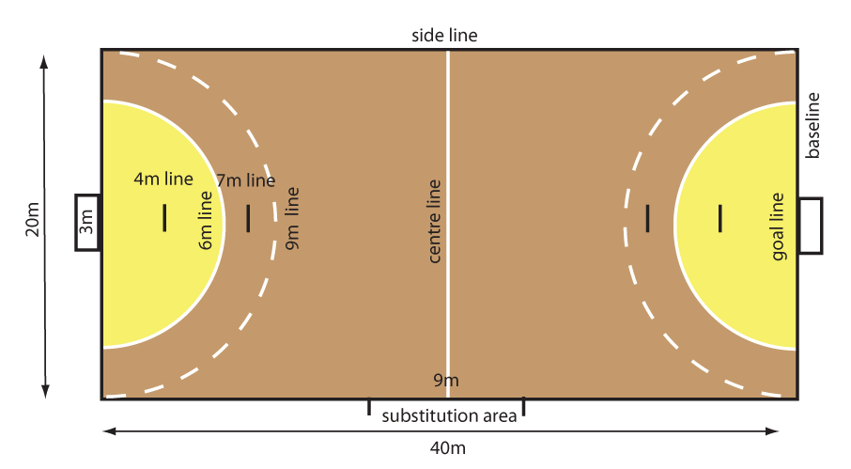
- Court size and lines:

What is the size of the court? ____________________________________

The goal area is the same as the: _________________________________

Can players enter the Goal Area? Yes or No

7m Line: __________________________________________________

9m Line: __________________________________________________

What is the size of an official ball used? _____________________________

- The Game:

Players are allowed how many steps? ________________________________________

Can the players dribble the ball? ___________________________________________

Is double dribble a violation? Yes or No

How long can a player hold the ball before making a move? _________________________

Which player can make contact with the ball with their foot? ________________________

- Rules and Violations:

Players are not allowed to: _______________________________________________

_______________________________________________

Lists 3 violations:

1. ________________________ 2) ___________________ 3) _________________

What is considered Progressive Punishment? ___________________________________

__________________________________________________________________

Yellow card = ________________________________________________________

Red card = __________________________________________________________

- Types of passes:

Team Handball is a _________________ Game: List the type of passes:

____________________________________________________

____________________________________________________

- When to take a Penalty shot:

You would take a “Free-Throw” penalty shot for the following reasons:

- __________________________________________________

- __________________________________________________

- __________________________________________________

You would take a 7m penalty shot for the following reasons:

- __________________________________________________

- __________________________________________________

- __________________________________________________

Enjoy the game of Team Handball!!!!!

