Basketball Name: _________________________
Team Sports/General PE
Date: ____________ Period _____

- History:

Inventor of basketball: ___________________________________

Year basketball was invented: _______________________

What was the first basketball and basket made of: _____________________________

- Scoring:

Name the 3 types of scoring opportunities:

- _____________________

- ________________________

- ________________________

- Skills:

There are several different types of skills in basketball; name them:

- ______________________ d. _______________________

- __________________________ e. __________________________

- __________________________ f. ___________________________

- Fouls:

Name the type of fouls someone can get called for:

- _______________________ 3. ______________________

- __________________________ 4. __________________________

- Violations:

Name three ways a referee can call you for a violation:

- _____________________

- ________________________

- ________________________

- Terms:

Understand basic terms/vocabulary that may be used in many situations:

- ______________________ d. _______________________

b. __________________________ e. ___________________________

c. __________________________ f. ___________________________

Name two types of Defenses:

- _____________________

- ________________________

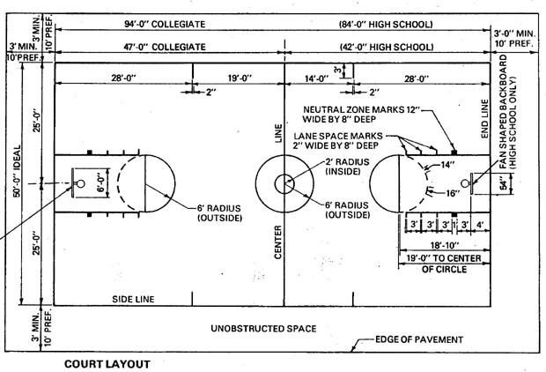
- Court Size: Know size of court length & width (high school and collegiate)

- Height of regular size rim? ______________________________

- Referee Signals:

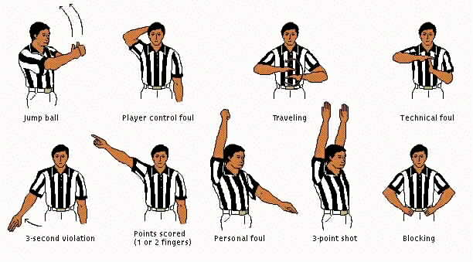

- Today verses the Past:

How is today so different then the past in the game of basketball?

________________________________________________________

________________________________________________________

________________________________________________________

Enjoy the game of basketball!!!!!

