Badminton Name: _________________________
Team Sports/General PE
Date: ____________ Period _____

- History:

Many years ago…what game was comprised of a shuttlecock that was batted back and forth

by multiple players?
___________________________________

In what year ________ did the __________ _____ ____________, officially

introduced this new fad to England at a party on his estate.

What year did the IBF start? _____________

What year saw the first official IBF tournament? _____________

What year did badminton make its first Olympic debut? _____________

- Rules & Regulations:

A badminton match is played best of ____________ games.

How does a team determine first serve or choice of side?

____________________________ or ________________________

What is the object of the badminton game? ________________________

______________________________________________________

A rally can be lost by: _______________________________________

______________________________________________________

- Scoring Formats:

Name the two scoring formats: 1) _____________ & 2) _____________

Explain the two types:

Service: _________________________________________________

______________________________________________________

Rally: __________________________________________________

______________________________________________________

- Serving Rules:

A badminton serve is always done: __________________________

Line shots in badminton serves or rallies are considered in or out? ________

A serve that strikes the net and lands in the opponent’s court is considered a

_______________________ serve.

During a serve, players must stand ______________________________

What type of serves is only permitted? _________________________

- How to keep score:

Do players serve from the left or right side in doubles? _________________

______________________________________________________

Should the two players switch service courts? Yes or No _____________

- Type of serves:

Explain the different type of serves:

High: ____________________________________________________

Flick or Drive: _______________________________________________________

Low: ______________________________________________________________

Name 4 ways you can be called for a violation (faults):

- ____________________________________________________

- _____________________________________________________________

- _____________________________________________________________

- _____________________________________________________________

- Terms:

Bird or birdie: ____________________________________________

Drop Shot: ______________________________________________

Let: ___________________________________________________

Shuttlecock: _____________________________________________

Smash: _________________________________________________

Wood shot: ______________________________________________

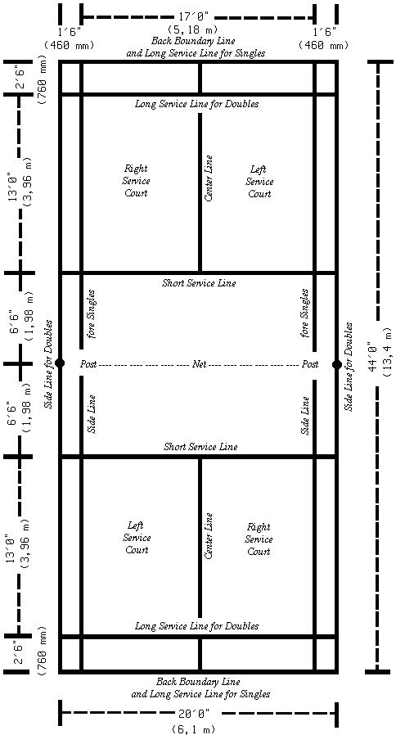
- Court Size: Know size of court length & width for a doubles court:

Double Court Size: ___________________

- Double court positions:

Name the two different court positions:

1 ) ______________________

2) _______________________

Badminton is a SERIOUS Game!!!!!

